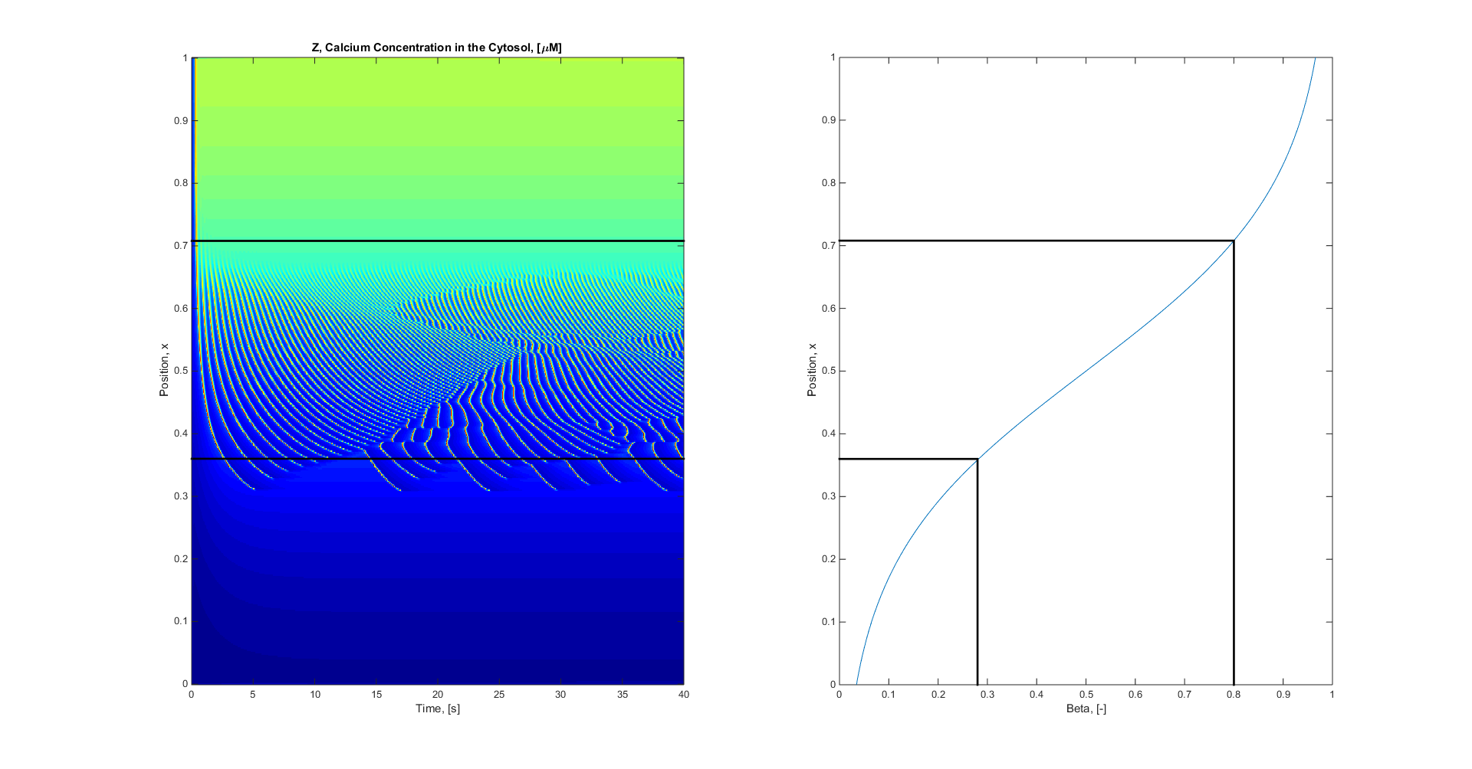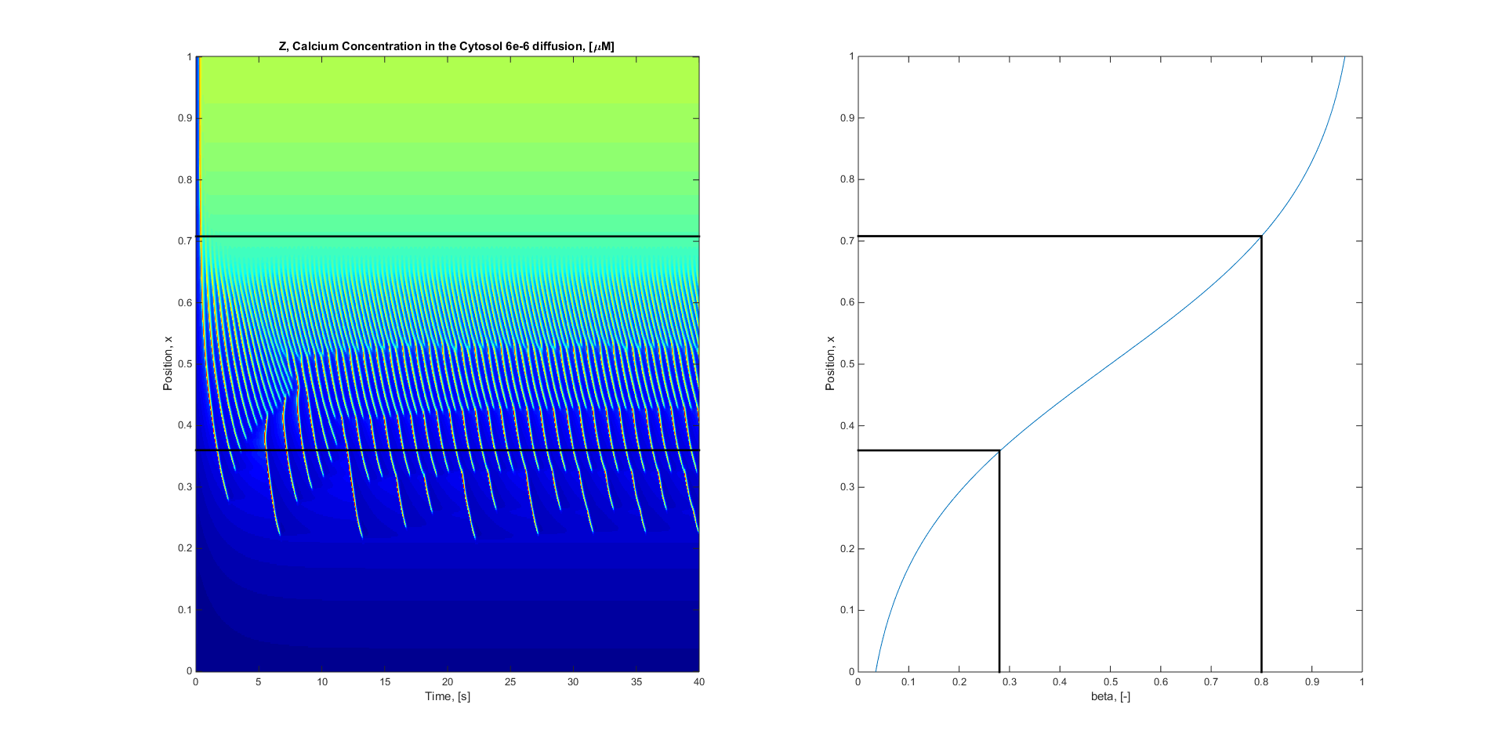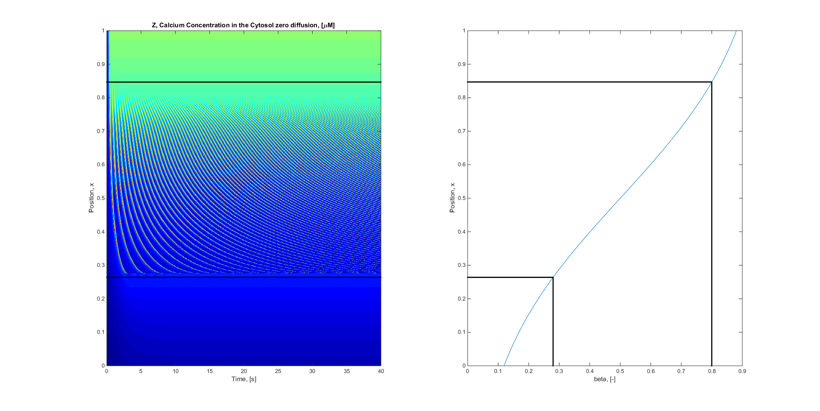

Electro Diffusion, Simple diffusion, Zero Diffusion,

Wondering why it Is discontinuous? Zoom in on the red block



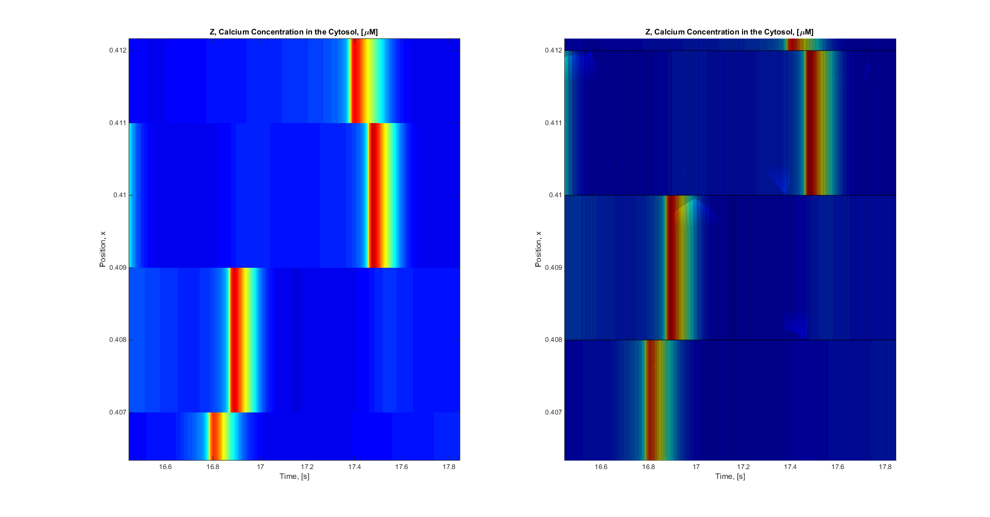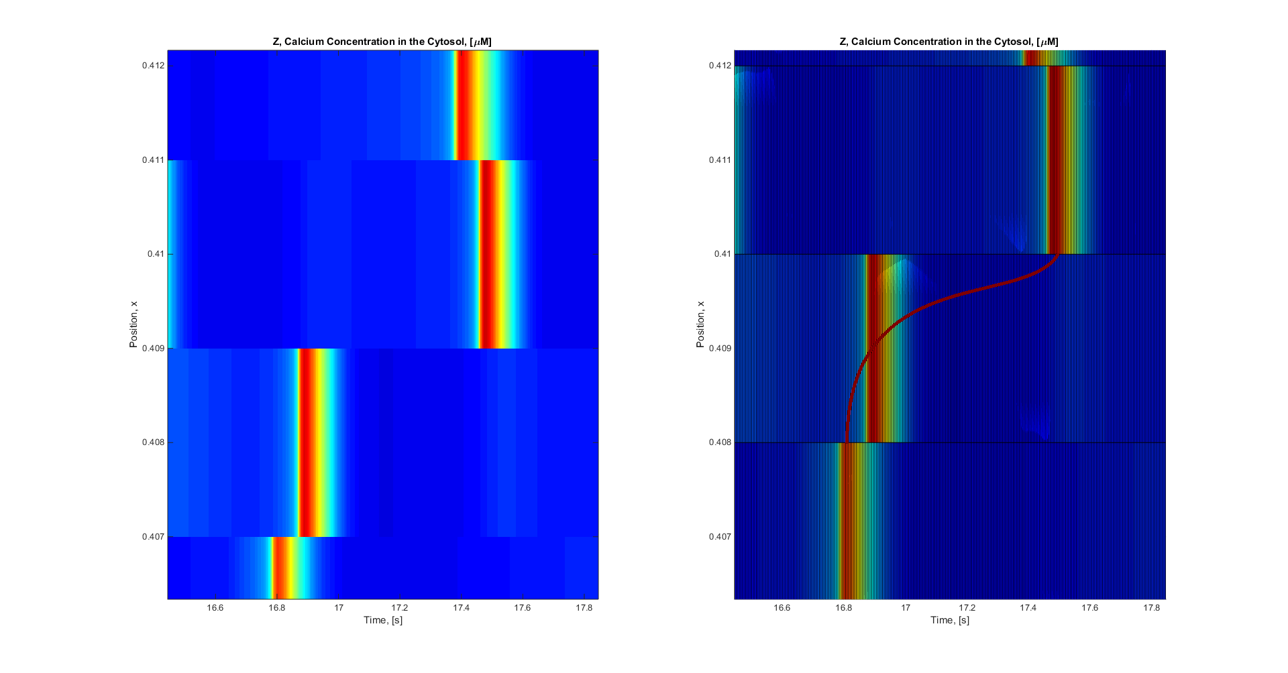

You can see that the grid is actually not that well defined in the vertical direction (RHS has grid the difference is Imagesc (LHS plot) Averages around points)

Below is what I expect it would be if I did it more defined only problem is that this simulation took 3 hours alone. I need to optimise the code into C